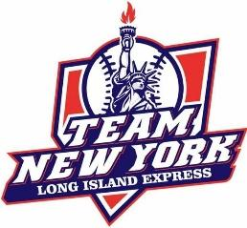 | Vanessa Ramsaran  CLASS OF 2024  POSITIONS: Centerfield, Leftfield, Rightfield, Second base
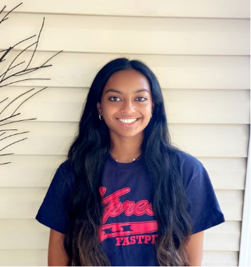 | Walt Whitman High School  301 W Hills Rd, Huntington Station, NY 11746  GPA: 4.0 SAT/ACT: TBD  GUIDANCE COUNSELOR Carolyn Dooley VARSITY COACH Ralph Miranda  CURRENT TEAM  Team New York 16u Bryggman  CONTACT: Noelle Bryggman (631) 307-6400 noellebryggman@gmail.com  ACCOMPLISHMENTS ACADEMIC AND ATHLETIC  Student of the Month March and April 2021  Starter on Varsity Softball - Freshman 2021, 2022  Ohio World Series MVP - July 2021  JV Volleyball 2021-2022  National Junior Honor Society  National Language Honor Society  All Honors and AP classes since 2018  High Honor Roll status- 2018 to present time  Martial Arts Grand Champion 2013  Martial arts 1st place winner 2013, 2014, 2015, 2016, 2018, 2019(Brown Belt Division)  SUMMER 2022 TOURNAMENT SCHEDULE  June 18th & 19th New Jersey Father’s Day tournament  June 25th & 26th Long Island – Sandlot Showdown  July 8th, 9th & 10th Binghamton, NY – 2022 Stop DWI Tournament of Champions  July 16th & 17th Long Island – Angels in the Outfield  July 23rd & 24th Long Island – Amputee Warrior Tournament  July 30th & 31st New England’s Finest – Showcase Team Only
Vanessa Ramsaran
28 Carlow Street Huntington, NY 11743
(631) 925-7328
Vanessar419@aol.com

NCAA ID#: XXXXXXXXXX

PARENTS:
Bob Ramsaran
(631) 662- 8471
bramsaran@railworks.com
Michelle Ramsaran
(631) 374-3992
micheller16@aol.com

Height:5´5
Jersey #: 19
Bats: RIghty
Throws: Righty

PITCHING INSTRUCTOR
Coach Name

